 | Filing Reference : |  | GG/COMS/TS.2/13
 | Document Title : |  | Use-Case Realization Report (Analysis)  Manage Workflow Step
 | Version : |  | 1.0
 | Prepared By : |  | Alvin Chang
 | Date Created : |  | Monday, Jul 30th, 2011
Approved By :
 |  | Tran Ba Tien |  | Date
 |  | Project Manager |  | 30th Jul 2011

©2011 [Hoang Kim joint stock Company].
The information contained in this document is the property of [Hoang Kim joint stock Company]. The contents must not be reproduced, wholly or in part, for purposes other than for which it has been supplied, without the prior permission of [Hoang Kim joint stock Company], or, if it has been furnished under contract to another party, as expressly authorised under that contract. [Hoang Kim joint stock Company] shall not be liable for any errors or omissions.

Revision History
Date | Version | Description | Author
30/JUL/2011 | 1.0 | First version | Alvin Chang

Table of Contents
1. Brief Description 4
2. Flow of Events 4
3. Interaction Diagrams 4
3.1 Add Workflow 4
3.2 Refresh Workflow Page 5
3.3 Add Step 5
3.4 Modify Workflow Properties 6
3.5 Modify Step Properties 6
3.6 View Workflow 7
3.7 Modify Workflow-Step Relationship 7
3.8 Activate Step 8
3.9 Deactivate Step 8
3.10 Activate Workflow 8
3.11 Deactivate Workflow 9
4. Participating Objects 9
5. Class Diagrams 9
5.1 Manage Workflow-Step 9

Use-Case Realization Report
Manage Workflow-Step

Brief Description
This use case enables a department manager to manage the workflows and the steps included in the workflows. For workflows, this includes adding of new workflow, updating workflow properties, and activating / deactivating workflows. For steps, this includes adding of new steps, updating step properties, and activating / deactivating steps. It also includes the managing of the workflow-step relationships via a drag-drop interface.

Flow of Events
The standard flow of events for this use case and any exceptions are described in the following subsections. See section 3 for an overview of the participating Actors and Domain Objects.

2.1 Add Workflow
This use case shows how a new workflow is added to the system. All newly created workflows are activated by default.

2.1.1 Preconditions
1. User must be successfully logged in to the system
2. WorkflowMainPage has been initialized / refreshed. Refer to Use Case 2.2.

2.1.2 Standard Flow
- Department Manager addWorkflow() in WorkflowMainPage.
- This will trigger a showAddWorkflow() in the WorkflowMainController, and it in turn will subsequently call show() for the WorkflowPropertiesPage.
- Department Manager will then enterWorkflowProperties() into the WorkflowPropertiesPage.
- This will trigger an addWorkflow() to WorkflowMainController, which in turn calls addWorkflow() to WorkflowController, which will call createWorklow() in Workflow object.
- WorkflowMainController will then hide() WorkflowPropertiesPage, and refreshWorkflowPage() for WorkflowMainPage.
- This marks the end of this use case.

2.1.3 Exception
1. If error in creating workflow, an error message will be shown to the user
2. If error in refreshing workflow page, refer to use case 2.2

2.2 Refresh Workflow Page
This use case initializes / refreshes the WorkflowMainPage boundary object, and populates it with the workflow and step information.

2.2.1 Preconditions
1. User must be successfully logged in to the system

2.2.2 Standard Flow
- Department Manager initiate() WorkflowMainPage.
- This triggers initializeWorkflowPage() to WorkflowMainController, which getListOfAllWorkflows() from WorkflowController, which subsequently calls getWorkflow() from Workflow.
- MainController then calls getListOfAllSteps() to StepController, which getStep() from Step.
- WorkflowMainController then refreshWorkflowPage() to WorkflowMainPage.
- This marks the end of this use case.

2.2.3 Exception
1. if error in getting list of workflows, an error message will be shown to the user.
2. if error in getting list of steps, an error message will be shown to the user.

2.3 Add Step
This use case shows how a new step is added to the system. All newly created steps are activated by default.

2.3.1 Preconditions
1. User must be successfully logged in to the system
2. WorkflowMainPage has been initialized. Refer to Use Case 2.2.

2.3.2 Standard Flow
- Department Manager addStep() to WorkflowMainPage, which calls showAddStep() to WorkflowMainController, which in turn calls show() to StepPropertiesPage.
- Department Manager then enterStepProperties() to StepPropertiesPage, which calls addStep() to WorkflowMainController.
- This then calls addStep() to StepController, which calls createStep in Step.
- WorkflowMainController then hide() StepPropertiesPage and refreshWorkflowPage() in WorkflowMainPage.
- This marks the end of this use case.

2.3.3 Exception
1. if error in creating step, an error message will be shown to the user.

2.4 Modify Workflow Properties
This use case shows how the workflow properties are modified.

2.4.1 Preconditions
1. User must be successfully logged in to the system
2. WorkflowMainPage has been initialized. Refer to Use Case 2.2.

2.4.2 Standard Flow
- Department Manager selects modifyWorkflowProperties() from WorkflowMainPage, which calls showModifyWorkflow() in WorkflowMainController, which in turn calls show() to WorkflowPropertiesPage.
- WorkflowMainController then calls getWorkflowFromID() from WorkflowController, which calls getWorkflow() from Workflow.
- WorkflowMainController then refreshWorkflowProperties() in WorkflowPropertiesPage.
- Department Manager now enterWorkflowProperties() to WorkflowPropertiesPage, which updateWorkflowProperties() in WorkflowMainController.
- This then calls updateWorkflow() in WorkflowController, which in turn calls updateWorkflow() in Workflow
- WorkflowMainController then hide() WorkflowPropertiesPage, and refreshWorkflowPage() in WorkflowMainPage.
- This marks the end of this use case.

2.4.3 Exception
1. if error in getting workflow properties, an error message will be shown to the user.
2. if error in updating workflow properties, an error message will be shown to the user.

  - Modify Step Properties
This use case shows how the step properties are modified.

2.5.1 Preconditions
1. User must be successfully logged in to the system
2. WorkflowMainPage has been initialized. Refer to Use Case 2.2.

2.5.2 Standard Flow
- Department Manager selects modifyStepProperties() from WorkflowMainPage, which calls showModifyStep() in WorkflowMainController, which in turn calls show() to StepPropertiesPage.
- WorkflowMainController then calls getStepFromID() from StepController, which calls getStep() from Step.
- WorkflowMainController then refreshStepProperties() in StepPropertiesPage.
- Department Manager now enterStepProperties() to StepPropertiesPage, which updateWorkflowProperties() in WorkflowMainController.
- This then calls updateStep() in StepController, which in turn calls updateStep() in Step
- WorkflowMainController then hide() StepPropertiesPage, and refreshWorkflowPage() in WorkflowMainPage.
- This marks the end of this use case.

2.5.3 Exception
1. if error in getting step properties, an error message will be shown to the user.
2. if error in updating step properties, an error message will be shown to the user.

2.6 View Workflow
This use case shows how a workflow is viewed.

2.6.1 Preconditions
1. User must be successfully logged in to the system
2. WorkflowMainPage has been initialized. Refer to Use Case 2.2.

2.6.2 Standard Flow
- Department Manager viewWorkflow() in WorkflowMainPage.
- This calls viewWorkflow() in WorkflowMainController, which then calls getWorkflowFromID() in WorkflowController, which in turn calls getWorkflow() in Workflow.
- WorkflowMainController then refreshWorkflowPage() in WorkflowMainPage.
- This marks the end of this use case.

2.6.3 Exception
1. if error in getting workflow, an error message will be shown to the user.

2.7 Modify Workflow-Step Relationship
This use case shows how a step is added to a workflow.

2.7.1 Preconditions
1. User must be successfully logged in to the system
2. WorkflowMainPage has been initialized. Refer to Use Case 2.2.

2.7.2 Standard Flow
- Department Manager addStepToWorkflow() to WorkflowMainPage().
- This will trigger addStepToWorkflow() in WorkflowMainController, which will then updateWorkflow() in WorkflowController, which in turn updateWOrkflow() in Workflow.
- WorkflowMainController then updateStep() ion StepController, which in turn updateStep() in Step.
- WorkflowMainController then refreshWorkflowPage() in WorkflowMainPage.
- This marks the end of this use case.

2.7.3 Exception
1. if error in updating workflow, an error message will be shown to the user.
2. if error in adding step to workflow, an error message will be shown to the user. And step will not be added to the workflow.

2.8 Activate Step
This use case shows how a step is activated.

2.8.1 Preconditions
1. User must be successfully logged in to the system
2. WorkflowMainPage has been initialized. Refer to Use Case 2.2.

2.8.2 Standard Flow
- Department Manager activateStep() in WorkflowMainPage
- This then calls activate Step() in WorkflowMainController which calls activateStep in StepController, which in turn calls activateStep in Step.
- WorkflowMainController then refreshWorkflowPage() in WorkflowMainPage.
- This marks the end of this use case.

2.8.3 Exception
1. if step is already activated, no action taken. A message will be shown to the user stating so.
2. if error in updating activation status, an error message will be shown to the user.

2.9 Deactivate Step
This use case shows how a step is deactivated

2.9.1 Preconditions
1. User must be successfully logged in to the system
2. WorkflowMainPage has been initialized. Refer to Use Case 2.2.

2.9.2 Standard Flow
- Department Manager deactivateStep() in WorkflowMainPage
- This then calls deactivate Step() in WorkflowMainController which calls deactivateStep in StepController, which in turn calls deactivateStep in Step.
- WorkflowMainController then refreshWorkflowPage() in WorkflowMainPage.
- This marks the end of this use case.

2.9.3 Exception
1. if step is already deactivated, no action taken. A message will be shown to the user stating so.
2. if error in updating activation status, an error message will be shown to the user.

2.10 Activate Workflow
This use case shows how a workflow is activated.

2.10.1 Preconditions
1. User must be successfully logged in to the system
2. WorkflowMainPage has been initialized. Refer to Use Case 2.2.

2.10.2 Standard Flow
- Department Manager activateWorkflow() in WorkflowMainPage
- This then calls activateWorkflow() in WorkflowMainController which calls activateWorkflow in WorkflowController, which in turn calls activateWorkflow in Workflow.
- WorkflowMainController then refreshWorkflowPage() in WorkflowMainPage.
- This marks the end of this use case.

2.10.3 Exception
1. if workflow is already activated, no action taken. A message will be shown to the user stating so.
2. if error in updating activation status, an error message will be shown to the user.

2.11 Deactivate Workflow
This use case shows how a workflow is deactivated

2.11.1 Preconditions
1. User must be successfully logged in to the system
2. WorkflowMainPage has been initialized. Refer to Use Case 2.2.

2.11.2 Standard Flow
- Department Manager deactivateWorkflow() in WorkflowMainPage
- This then calls deactivateWorkflow() in WorkflowMainController which calls deactivateWorkflow in WorkflowController, which in turn calls deactivateWorkflow in Workflow.
- WorkflowMainController then refreshWorkflowPage() in WorkflowMainPage.
- This marks the end of this use case.

2.11.3 Exception
1. if workflow is already deactivated, no action taken. A message will be shown to the user stating so.
2. if error in updating activation status, an error message will be shown to the user.

Interaction Diagrams

Add Workflow
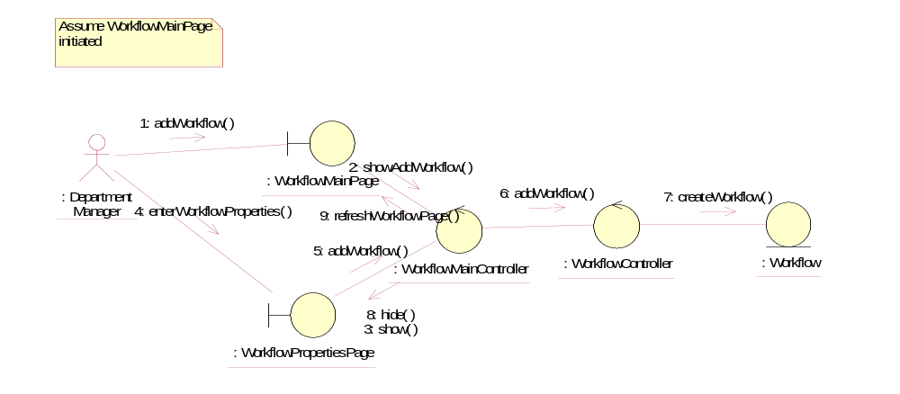

Refresh Workflow Page
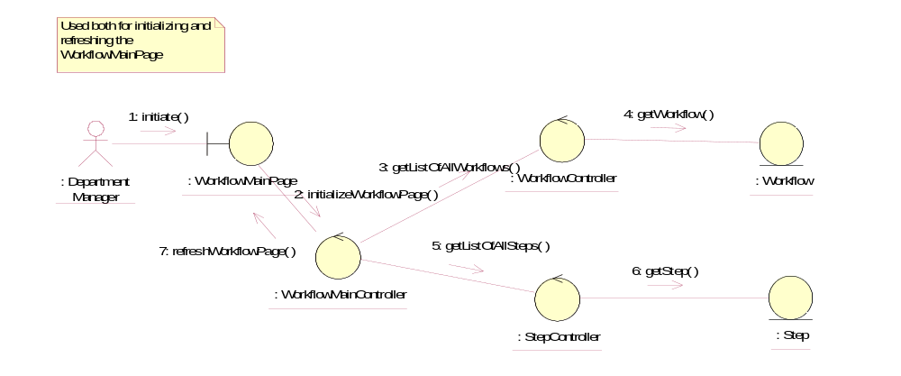

Add Step
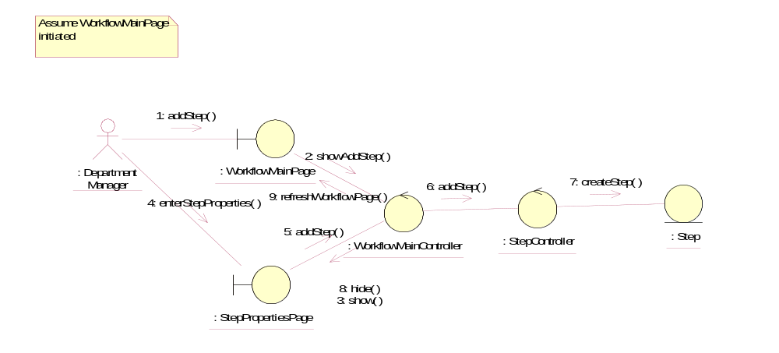

Modify Workflow Properties
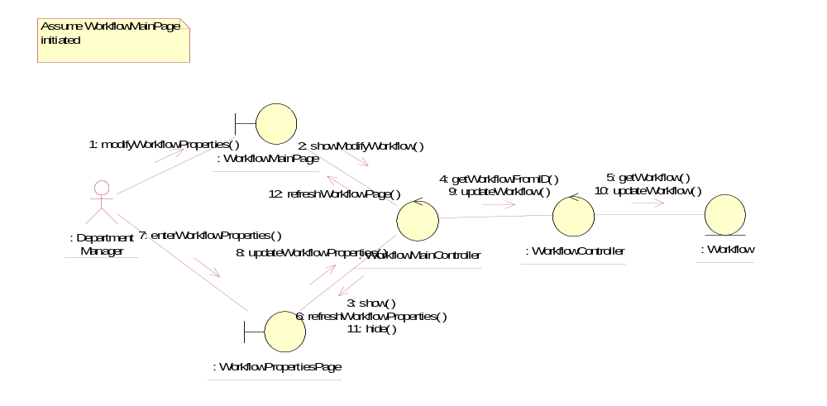

Modify Step Properties
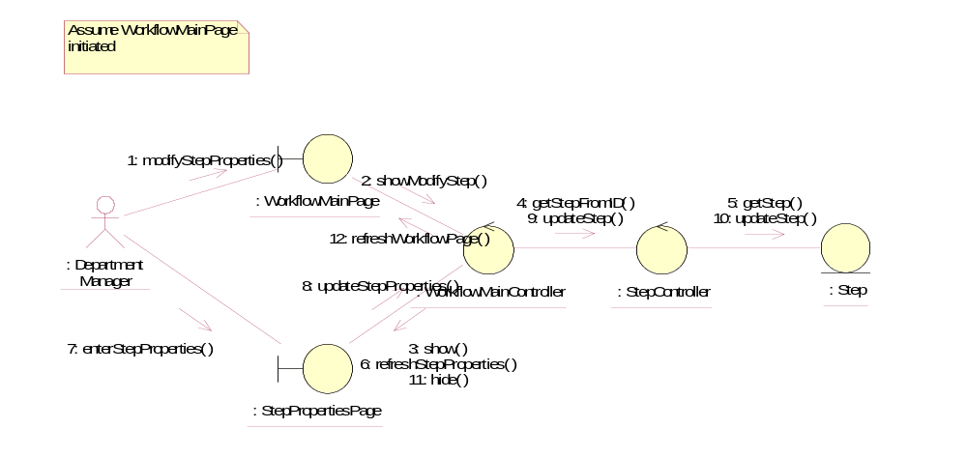

View Workflow
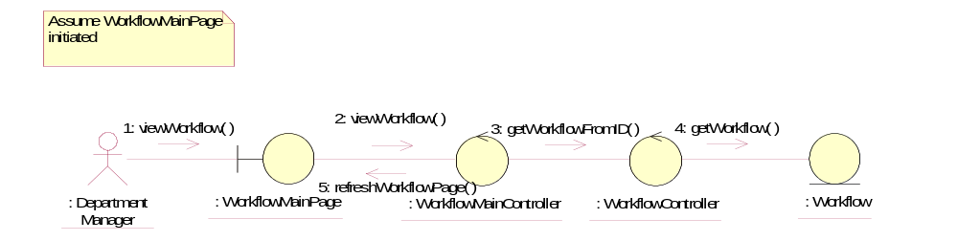

Modify Workflow-Step Relationship
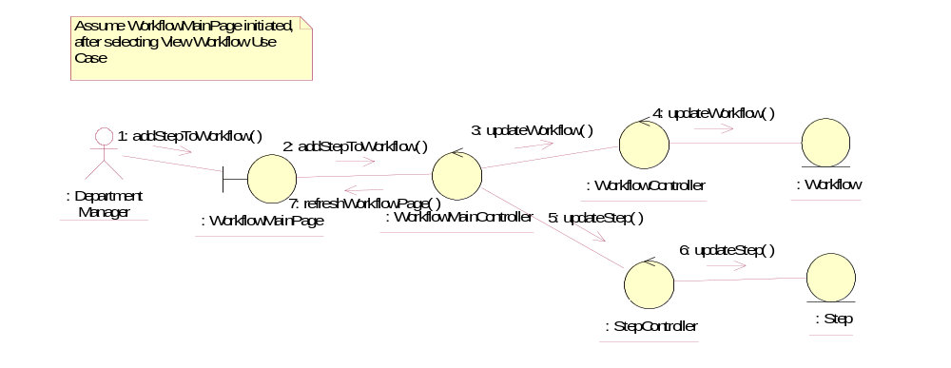

Activate Step
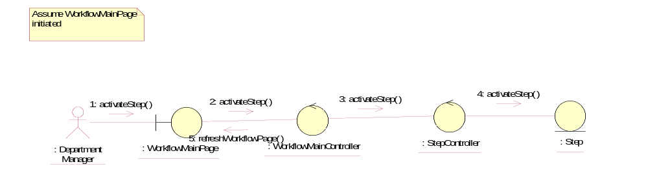

Deactivate Step
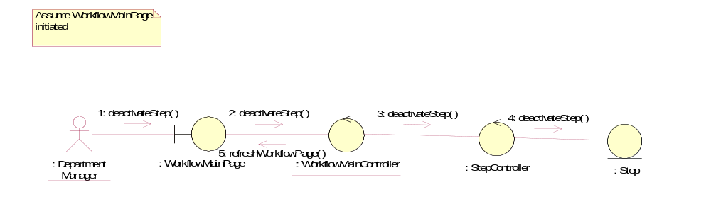

Activate Workflow
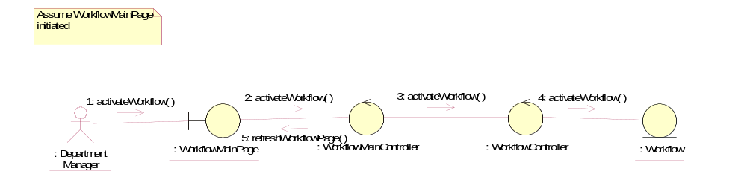

Deactivate Workflow
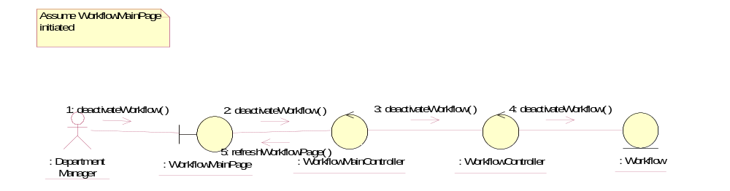

Participating Objects
: Department Manager
This actor represents the Department Manager of Golden Gravure.

: Step
This object contains information about the step.

: StepController
This object controls the operations of the step object.

: StepPropertiesPage
This represents the boundary object where the Department Manager will add / de(activate) the steps.

: Workflow
This object contains information about the workflow.

: WorkflowController
This object controls the operations of the workflow objects.

: WorkflowMainController
This object acts as the middleman between the boundary objects and other controllers

: WorkflowMainPage
This represents the boundary object where the Department Manager will launch the other boundary objects

: WorkflowPropertiesPage
This represents the boundary object where the Department Manager will add / de(activate) the workflows.

Class Diagrams

Manage Workflow-Step
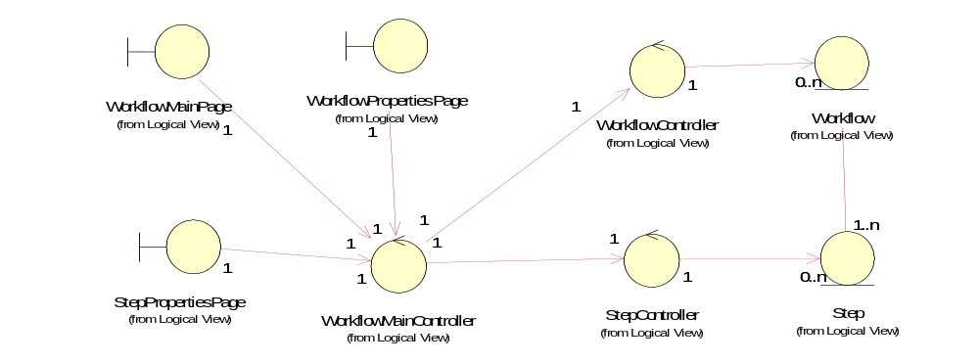

Derived Requirements
None

